Sample Letter- Communication to Families

Greetings families,

To guide the Everett Public Schools’ continuous improvement process, each year schools survey students, families, and staff. This information helps us to understand our specific strengths and challenges that impact school quality. The School Stakeholder Annual Survey is only one of many pieces of data analyzed by school leaders and staff. In addition to survey data, student achievement, attendance, discipline, and program data is evaluated to create School Improvement Plan goals.

Below is the link to our anonymous, multiple-choice family survey. We ask that you please complete and submit the survey by **April 4.** If you have more than one student in Everett Public Schools, please complete a survey for each school your student attends so that they can benefit from your feedback.

Thank you for partnering with us,

School Principal/contact information

<https://surveys.panoramaed.com/everett/family25/surveys>[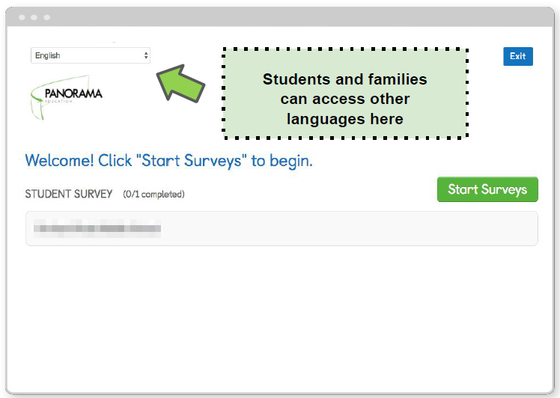](https://surveys.panoramaed.com/everett/family22)